Schindel, Nikolaus - Zwei neue Militärdiplome aus der Provinz Moesia superior, in: Tyche 13, 1998, S. 221–227
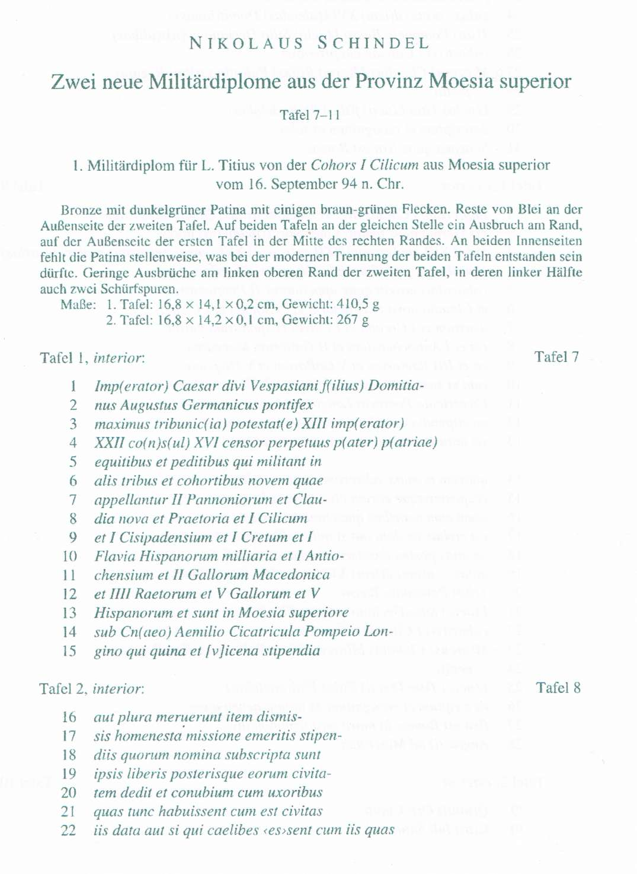

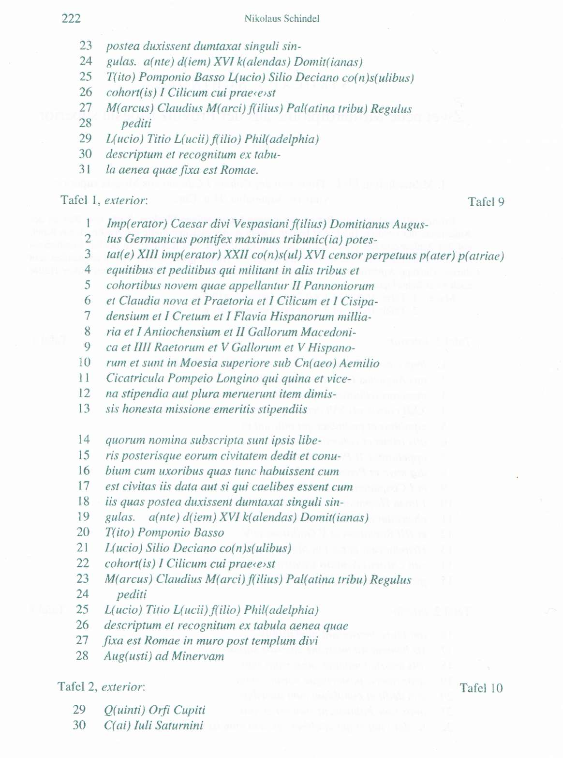

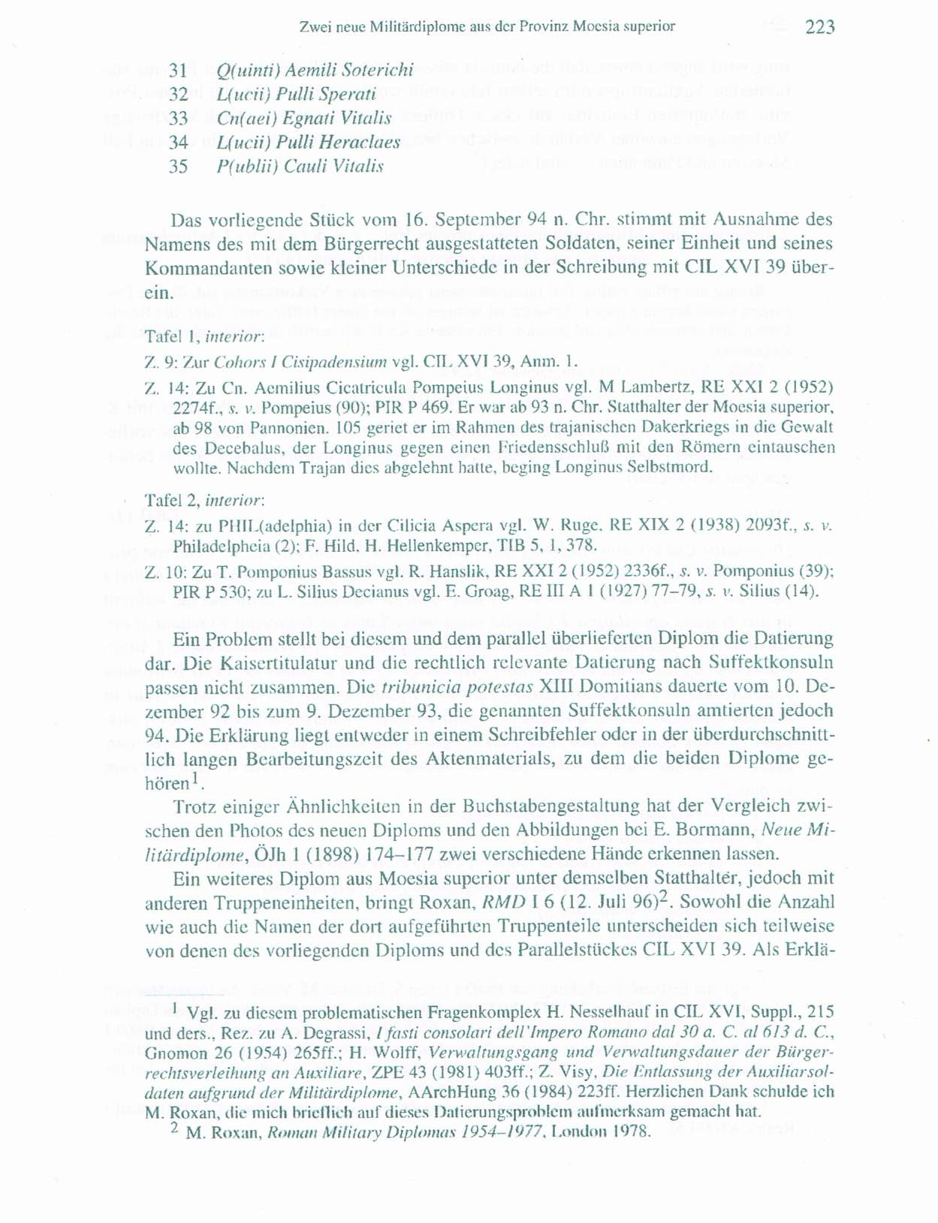

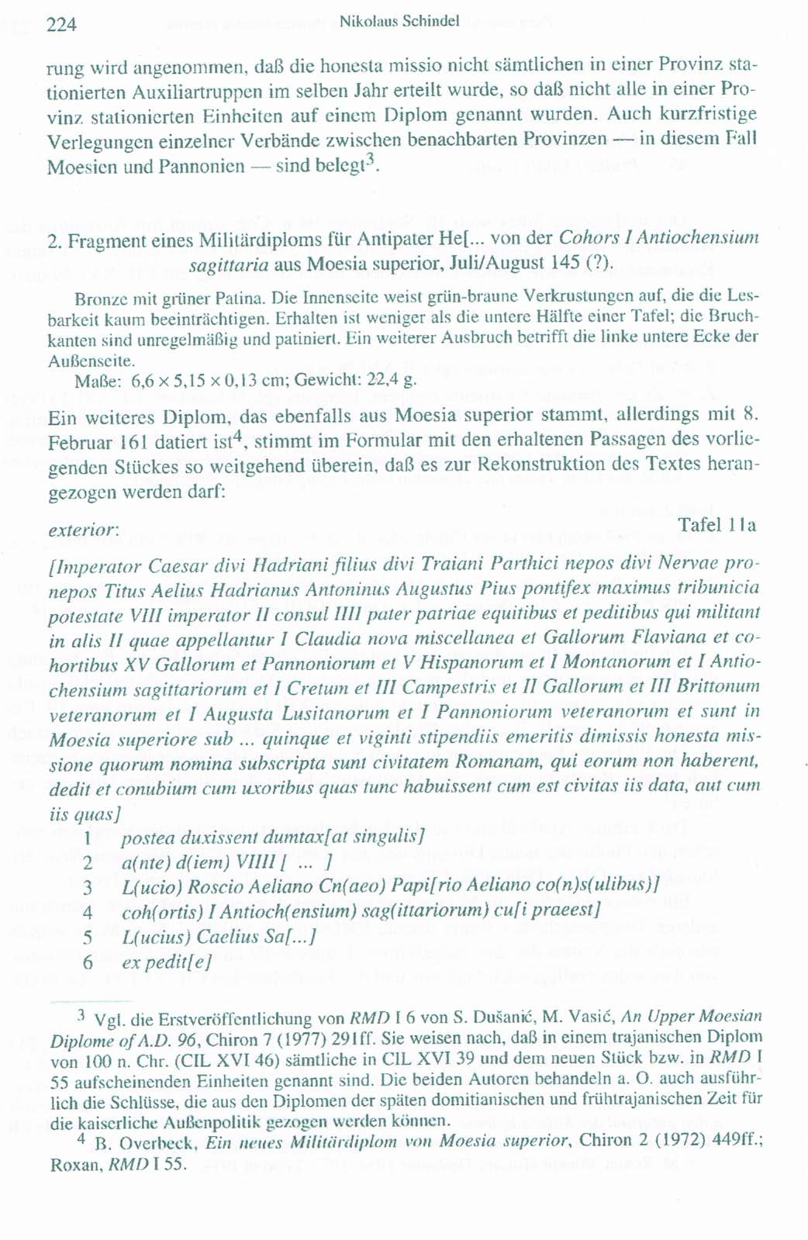

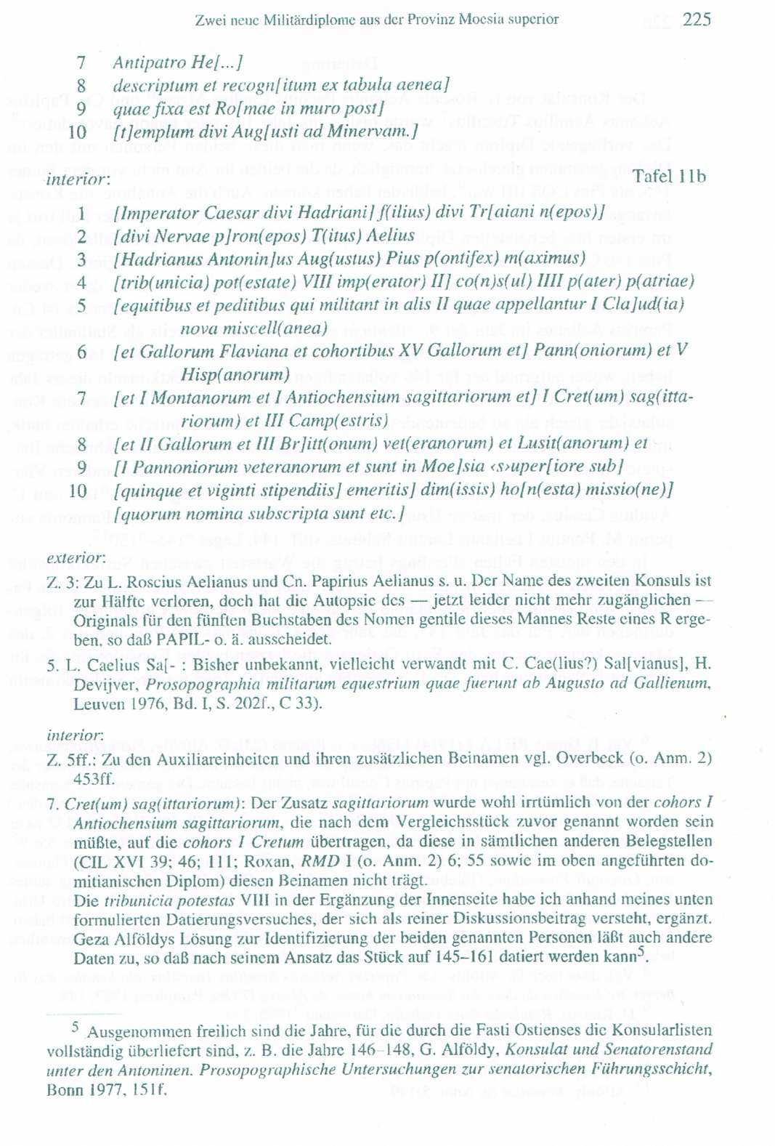

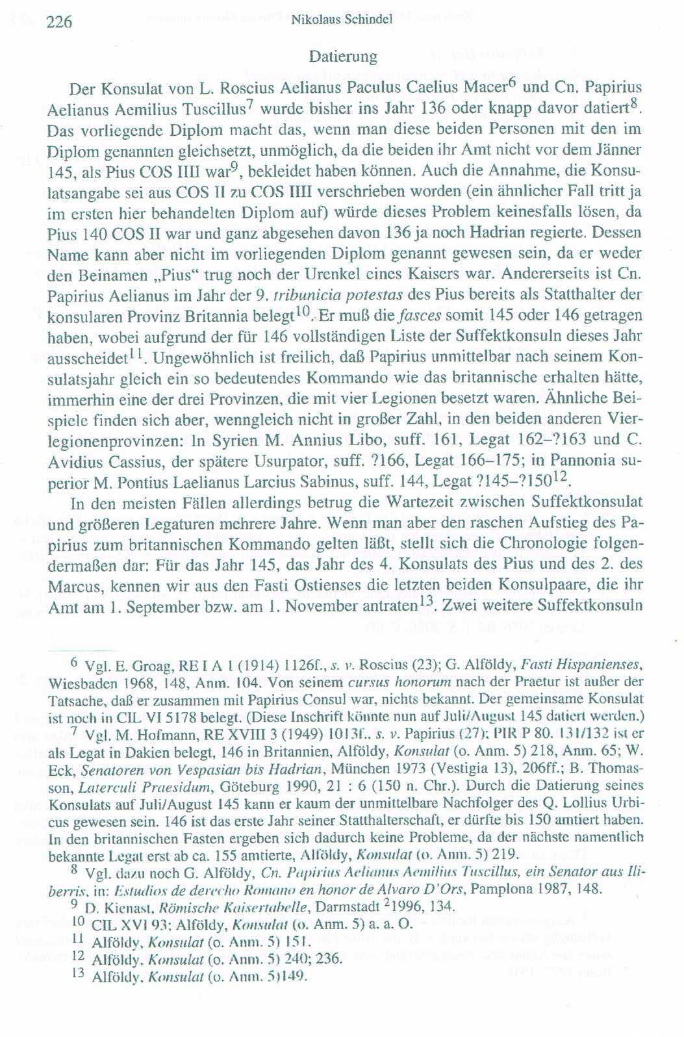

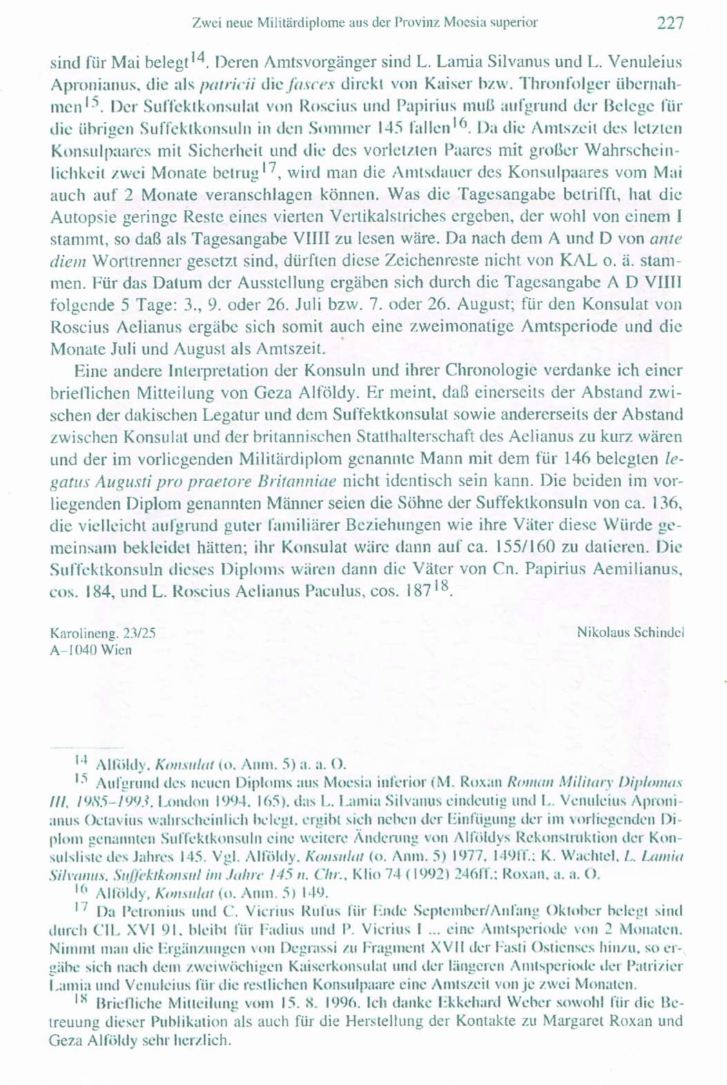

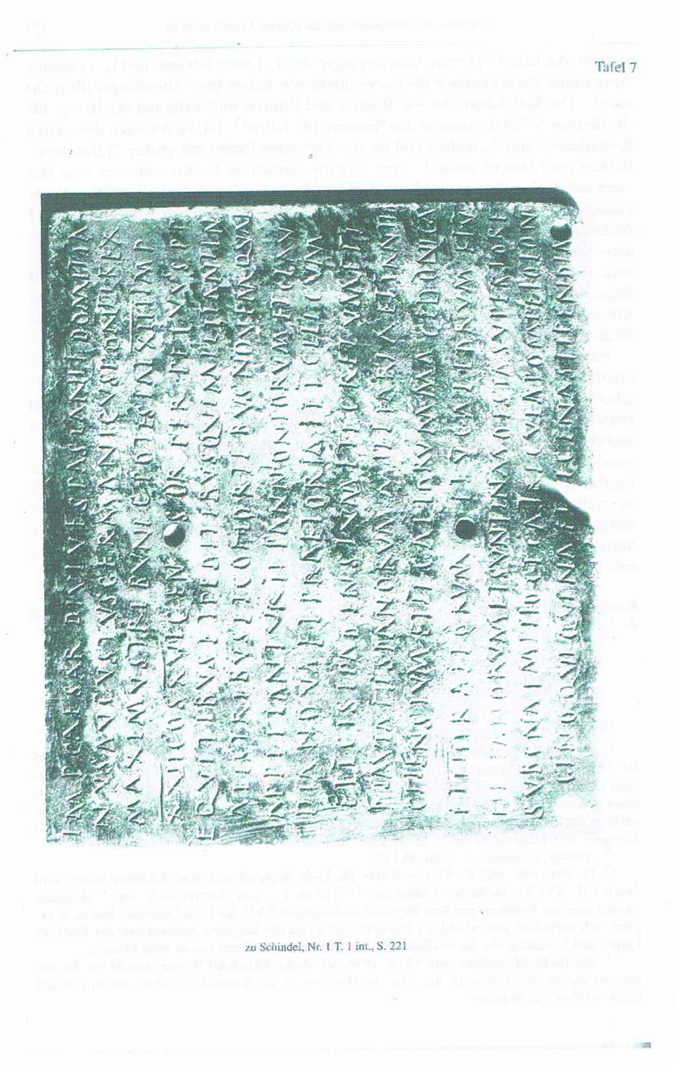

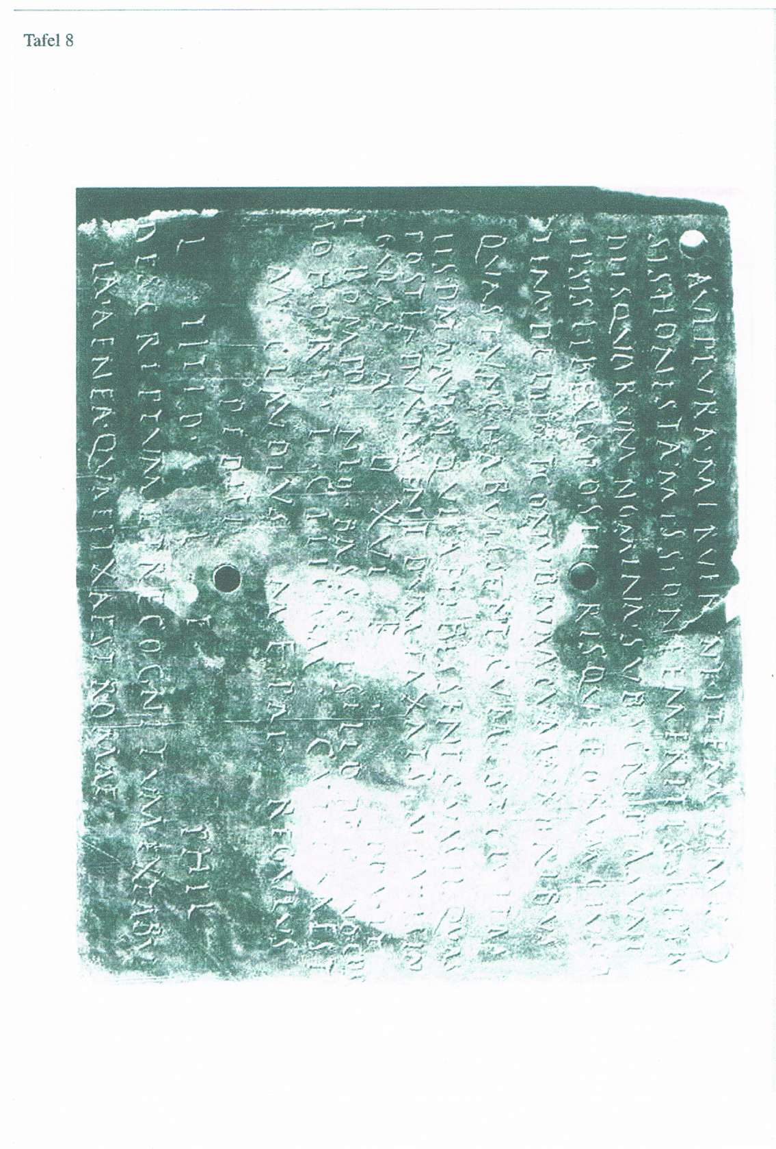

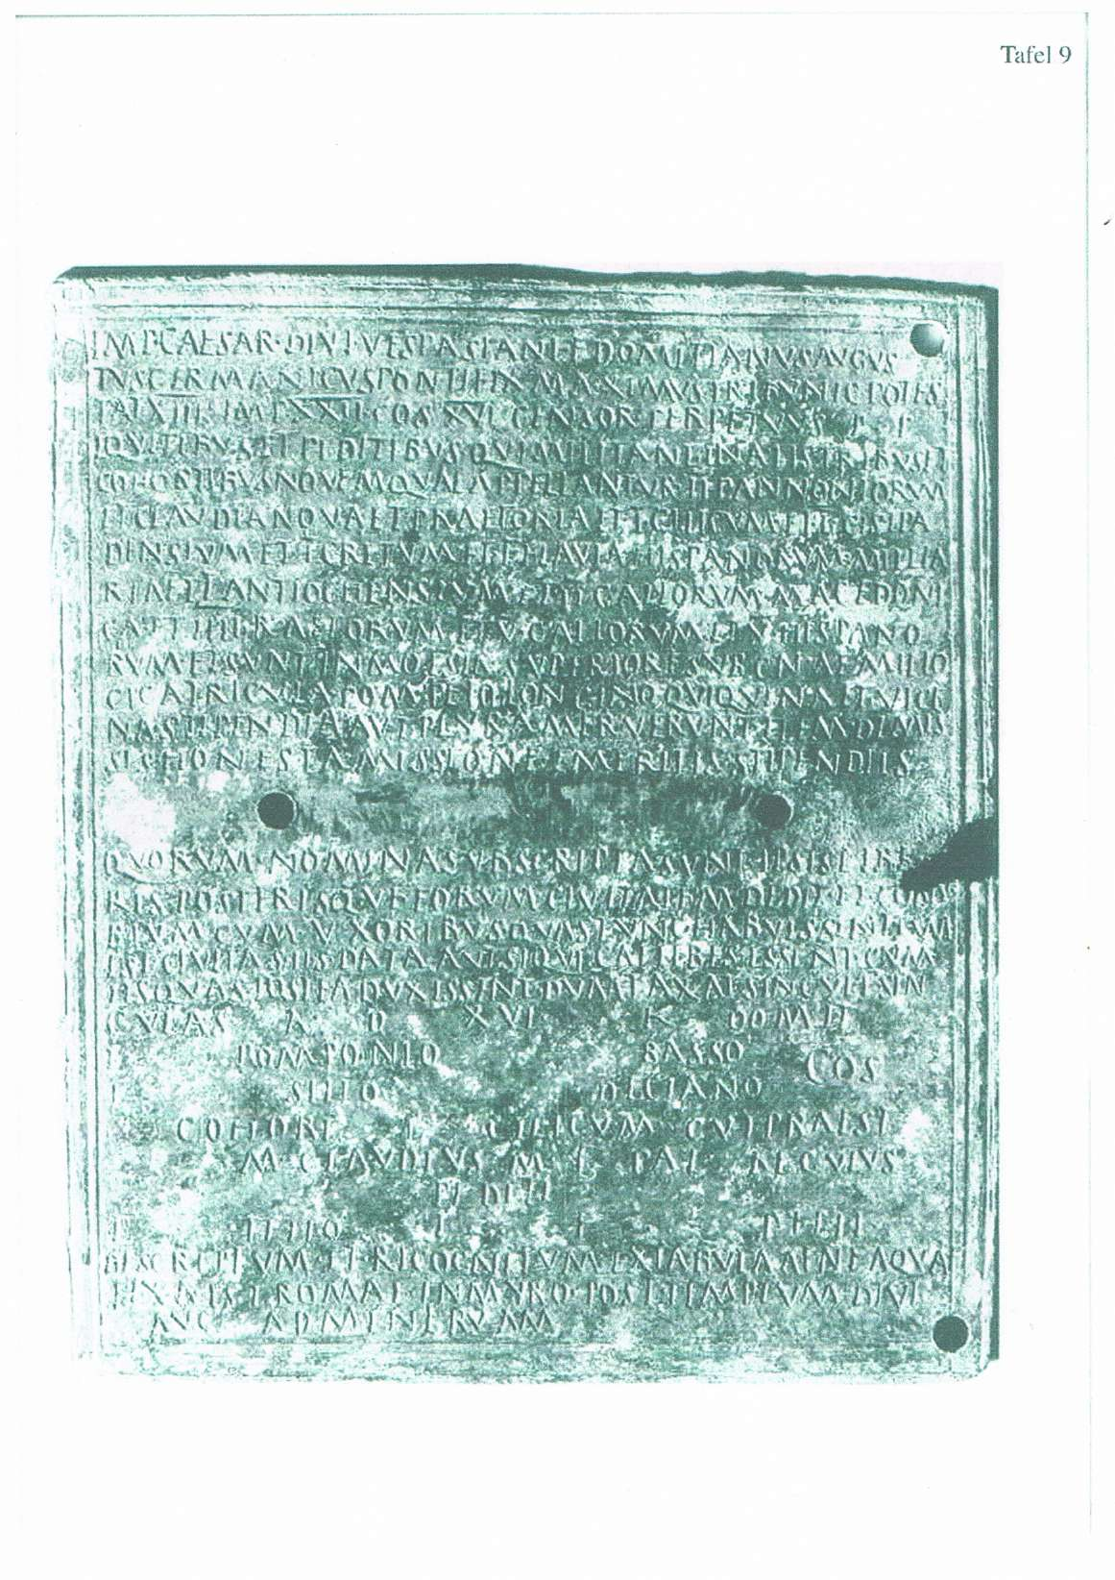

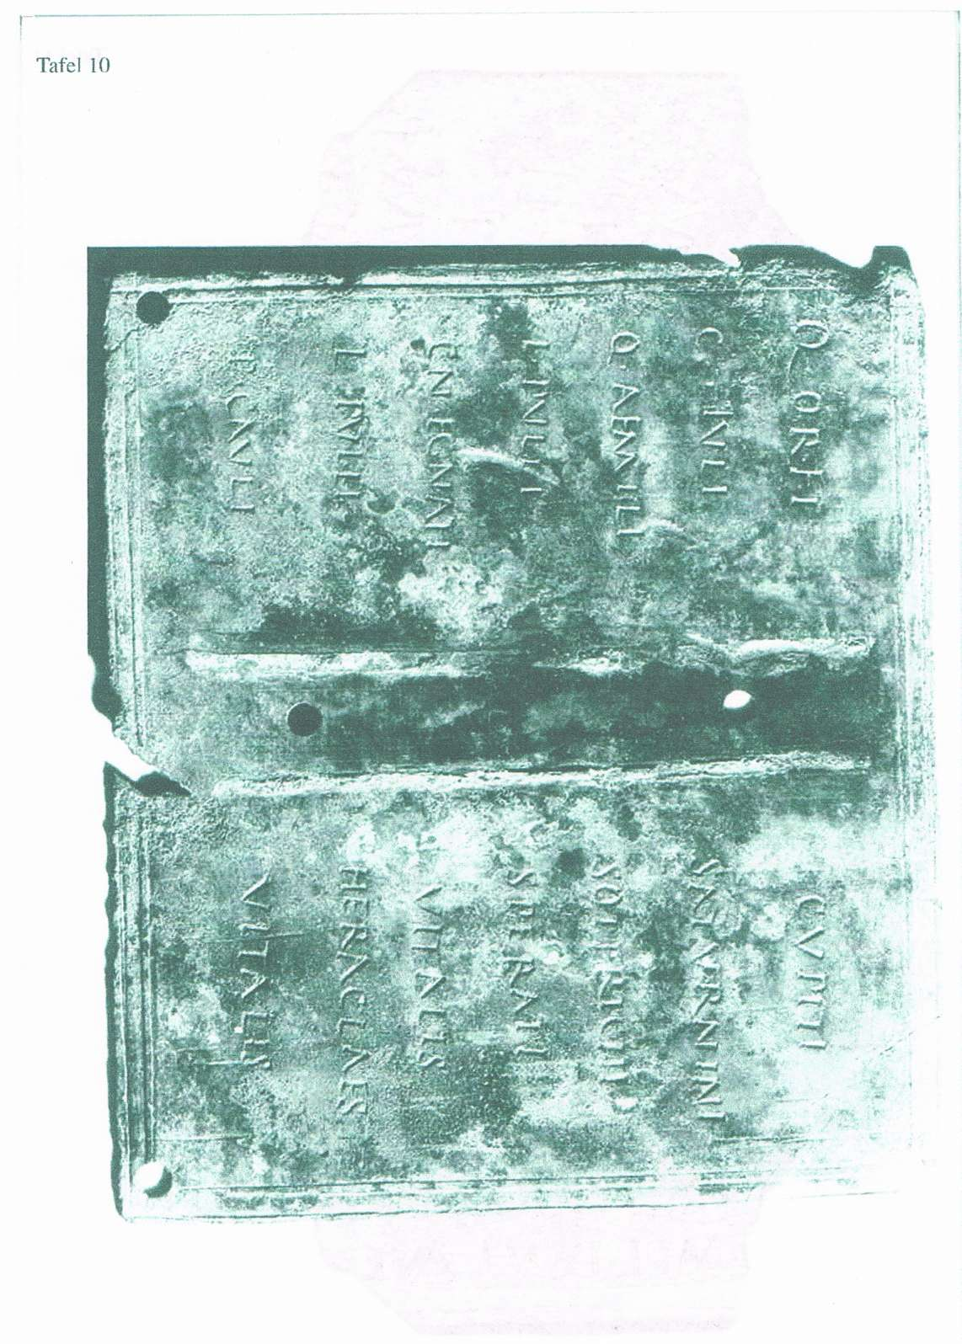

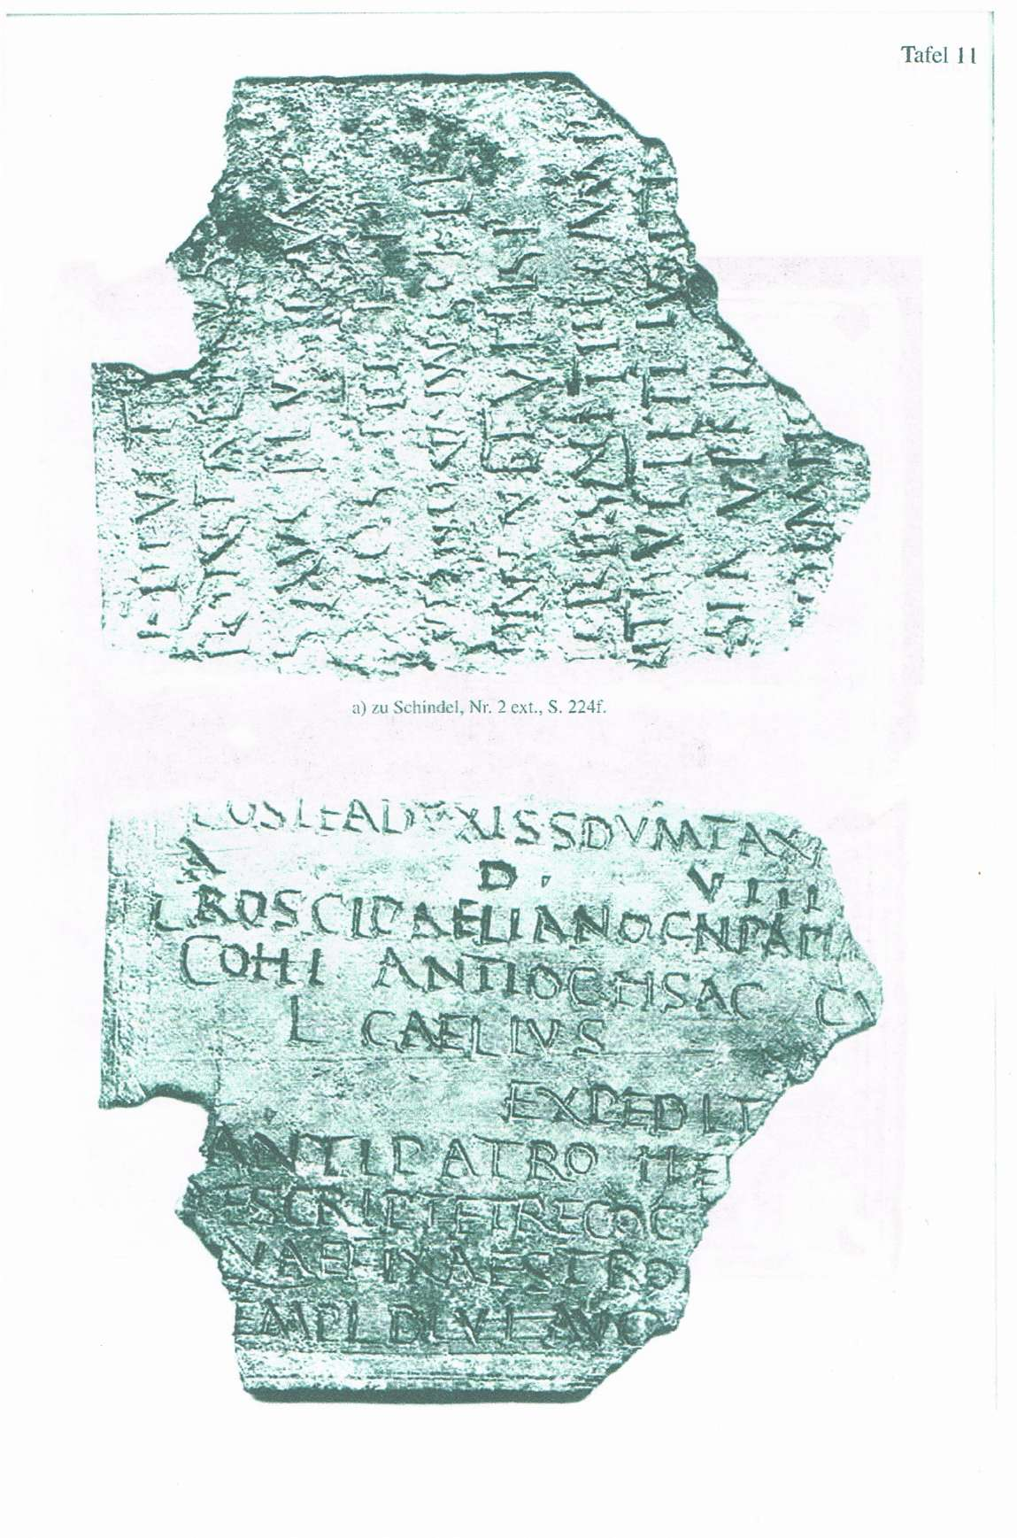

Трибунскую власть получал 21 раз (первый раз — 27 октября 97 г. еще при жизни Нервы, продлена 10 декабря 97 г., затем — ежегодно 10 декабря).
Император: I (28 января 98 г.), II (101 г.), III—IV (102 г.), V (104 г.), VI (106 г.), VII (114 г.), VIII—XI (?) (115 г.), XII—XIII (?) (116 г.).
Консул: I (91 г.), II (98 г.), III (100 г.), IV (101 г.), V (103 г.), VI (112 г.).
Победоносные титулы:
Germanicus — с октября 97 г.;
Dacicus — с конца 102 г.;
Parthicus — со 116 г.;

INCLUDEPICTURE "http://t0.gstatic.com/images?q=tbn:ANd9GcTDT1jpfS6n_Y4NmsXFnf0dV2uAk854tEHeOSaIXPxUCt7qxHu5xaSaZA" \* MERGEFORMATINET INCLUDEPICTURE "http://t0.gstatic.com/images?q=tbn:ANd9GcTDT1jpfS6n_Y4NmsXFnf0dV2uAk854tEHeOSaIXPxUCt7qxHu5xaSaZA" \* MERGEFORMATINET INCLUDEPICTURE "http://t0.gstatic.com/images?q=tbn:ANd9GcTDT1jpfS6n_Y4NmsXFnf0dV2uAk854tEHeOSaIXPxUCt7qxHu5xaSaZA" \* MERGEFORMATINET INCLUDEPICTURE "http://t0.gstatic.com/images?q=tbn:ANd9GcTDT1jpfS6n_Y4NmsXFnf0dV2uAk854tEHeOSaIXPxUCt7qxHu5xaSaZA" \* MERGEFORMATINET INCLUDEPICTURE "http://t0.gstatic.com/images?q=tbn:ANd9GcTDT1jpfS6n_Y4NmsXFnf0dV2uAk854tEHeOSaIXPxUCt7qxHu5xaSaZA" \* MERGEFORMATINET INCLUDEPICTURE "http://t0.gstatic.com/images?q=tbn:ANd9GcTDT1jpfS6n_Y4NmsXFnf0dV2uAk854tEHeOSaIXPxUCt7qxHu5xaSaZA" \* MERGEFORMATINET INCLUDEPICTURE "http://t0.gstatic.com/images?q=tbn:ANd9GcTDT1jpfS6n_Y4NmsXFnf0dV2uAk854tEHeOSaIXPxUCt7qxHu5xaSaZA" \* MERGEFORMATINET INCLUDEPICTURE "http://t0.gstatic.com/images?q=tbn:ANd9GcTDT1jpfS6n_Y4NmsXFnf0dV2uAk854tEHeOSaIXPxUCt7qxHu5xaSaZA" \* MERGEFORMATINET INCLUDEPICTURE "http://t0.gstatic.com/images?q=tbn:ANd9GcTDT1jpfS6n_Y4NmsXFnf0dV2uAk854tEHeOSaIXPxUCt7qxHu5xaSaZA" \* MERGEFORMATINET INCLUDEPICTURE "http://t0.gstatic.com/images?q=tbn:ANd9GcTDT1jpfS6n_Y4NmsXFnf0dV2uAk854tEHeOSaIXPxUCt7qxHu5xaSaZA" \* MERGEFORMATINET INCLUDEPICTURE "http://t0.gstatic.com/images?q=tbn:ANd9GcTDT1jpfS6n_Y4NmsXFnf0dV2uAk854tEHeOSaIXPxUCt7qxHu5xaSaZA" \* MERGEFORMATINET INCLUDEPICTURE "http://t0.gstatic.com/images?q=tbn:ANd9GcTDT1jpfS6n_Y4NmsXFnf0dV2uAk854tEHeOSaIXPxUCt7qxHu5xaSaZA" \* MERGEFORMATINET INCLUDEPICTURE "http://t0.gstatic.com/images?q=tbn:ANd9GcTDT1jpfS6n_Y4NmsXFnf0dV2uAk854tEHeOSaIXPxUCt7qxHu5xaSaZA" \* MERGEFORMATINET INCLUDEPICTURE "http://t0.gstatic.com/images?q=tbn:ANd9GcTDT1jpfS6n_Y4NmsXFnf0dV2uAk854tEHeOSaIXPxUCt7qxHu5xaSaZA" \* MERGEFORMATINET INCLUDEPICTURE "http://t0.gstatic.com/images?q=tbn:ANd9GcTDT1jpfS6n_Y4NmsXFnf0dV2uAk854tEHeOSaIXPxUCt7qxHu5xaSaZA" \* MERGEFORMATINET INCLUDEPICTURE "http://t0.gstatic.com/images?q=tbn:ANd9GcTDT1jpfS6n_Y4NmsXFnf0dV2uAk854tEHeOSaIXPxUCt7qxHu5xaSaZA" \* MERGEFORMATINET INCLUDEPICTURE "http://t0.gstatic.com/images?q=tbn:ANd9GcTDT1jpfS6n_Y4NmsXFnf0dV2uAk854tEHeOSaIXPxUCt7qxHu5xaSaZA" \* MERGEFORMATINET INCLUDEPICTURE "http://t0.gstatic.com/images?q=tbn:ANd9GcTDT1jpfS6n_Y4NmsXFnf0dV2uAk854tEHeOSaIXPxUCt7qxHu5xaSaZA" \* MERGEFORMATINET INCLUDEPICTURE "http://t0.gstatic.com/images?q=tbn:ANd9GcTDT1jpfS6n_Y4NmsXFnf0dV2uAk854tEHeOSaIXPxUCt7qxHu5xaSaZA" \* MERGEFORMATINET INCLUDEPICTURE "http://t0.gstatic.com/images?q=tbn:ANd9GcTDT1jpfS6n_Y4NmsXFnf0dV2uAk854tEHeOSaIXPxUCt7qxHu5xaSaZA" \* MERGEFORMATINET INCLUDEPICTURE "http://t0.gstatic.com/images?q=tbn:ANd9GcTDT1jpfS6n_Y4NmsXFnf0dV2uAk854tEHeOSaIXPxUCt7qxHu5xaSaZA" \* MERGEFORMATINET INCLUDEPICTURE "http://t0.gstatic.com/images?q=tbn:ANd9GcTDT1jpfS6n_Y4NmsXFnf0dV2uAk854tEHeOSaIXPxUCt7qxHu5xaSaZA" \* MERGEFORMATINET INCLUDEPICTURE "http://t0.gstatic.com/images?q=tbn:ANd9GcTDT1jpfS6n_Y4NmsXFnf0dV2uAk854tEHeOSaIXPxUCt7qxHu5xaSaZA" \* MERGEFORMATINET INCLUDEPICTURE "http://t0.gstatic.com/images?q=tbn:ANd9GcTDT1jpfS6n_Y4NmsXFnf0dV2uAk854tEHeOSaIXPxUCt7qxHu5xaSaZA" \* MERGEFORMATINET INCLUDEPICTURE "http://t0.gstatic.com/images?q=tbn:ANd9GcTDT1jpfS6n_Y4NmsXFnf0dV2uAk854tEHeOSaIXPxUCt7qxHu5xaSaZA" \* MERGEFORMATINET INCLUDEPICTURE "http://t0.gstatic.com/images?q=tbn:ANd9GcTDT1jpfS6n_Y4NmsXFnf0dV2uAk854tEHeOSaIXPxUCt7qxHu5xaSaZA" \* MERGEFORMATINET INCLUDEPICTURE "http://t0.gstatic.com/images?q=tbn:ANd9GcTDT1jpfS6n_Y4NmsXFnf0dV2uAk854tEHeOSaIXPxUCt7qxHu5xaSaZA" \* MERGEFORMATINET INCLUDEPICTURE "http://t0.gstatic.com/images?q=tbn:ANd9GcTDT1jpfS6n_Y4NmsXFnf0dV2uAk854tEHeOSaIXPxUCt7qxHu5xaSaZA" \* MERGEFORMATINET INCLUDEPICTURE "http://t0.gstatic.com/images?q=tbn:ANd9GcTDT1jpfS6n_Y4NmsXFnf0dV2uAk854tEHeOSaIXPxUCt7qxHu5xaSaZA" \* MERGEFORMATINET INCLUDEPICTURE "http://t0.gstatic.com/images?q=tbn:ANd9GcTDT1jpfS6n_Y4NmsXFnf0dV2uAk854tEHeOSaIXPxUCt7qxHu5xaSaZA" \* MERGEFORMATINET INCLUDEPICTURE "http://t0.gstatic.com/images?q=tbn:ANd9GcTDT1jpfS6n_Y4NmsXFnf0dV2uAk854tEHeOSaIXPxUCt7qxHu5xaSaZA" \* MERGEFORMATINET INCLUDEPICTURE "http://t0.gstatic.com/images?q=tbn:ANd9GcTDT1jpfS6n_Y4NmsXFnf0dV2uAk854tEHeOSaIXPxUCt7qxHu5xaSaZA" \* MERGEFORMATINET INCLUDEPICTURE "http://t0.gstatic.com/images?q=tbn:ANd9GcTDT1jpfS6n_Y4NmsXFnf0dV2uAk854tEHeOSaIXPxUCt7qxHu5xaSaZA" \* MERGEFORMATINET INCLUDEPICTURE "http://t0.gstatic.com/images?q=tbn:ANd9GcTDT1jpfS6n_Y4NmsXFnf0dV2uAk854tEHeOSaIXPxUCt7qxHu5xaSaZA" \* MERGEFORMATINET INCLUDEPICTURE "http://t0.gstatic.com/images?q=tbn:ANd9GcTDT1jpfS6n_Y4NmsXFnf0dV2uAk854tEHeOSaIXPxUCt7qxHu5xaSaZA" \* MERGEFORMATINET INCLUDEPICTURE "http://t0.gstatic.com/images?q=tbn:ANd9GcTDT1jpfS6n_Y4NmsXFnf0dV2uAk854tEHeOSaIXPxUCt7qxHu5xaSaZA" \* MERGEFORMATINET INCLUDEPICTURE "http://t0.gstatic.com/images?q=tbn:ANd9GcTDT1jpfS6n_Y4NmsXFnf0dV2uAk854tEHeOSaIXPxUCt7qxHu5xaSaZA" \* MERGEFORMATINET INCLUDEPICTURE "http://t0.gstatic.com/images?q=tbn:ANd9GcTDT1jpfS6n_Y4NmsXFnf0dV2uAk854tEHeOSaIXPxUCt7qxHu5xaSaZA" \* MERGEFORMATINET INCLUDEPICTURE "http://t0.gstatic.com/images?q=tbn:ANd9GcTDT1jpfS6n_Y4NmsXFnf0dV2uAk854tEHeOSaIXPxUCt7qxHu5xaSaZA" \* MERGEFORMATINET INCLUDEPICTURE "http://t0.gstatic.com/images?q=tbn:ANd9GcTDT1jpfS6n_Y4NmsXFnf0dV2uAk854tEHeOSaIXPxUCt7qxHu5xaSaZA" \* MERGEFORMATINET INCLUDEPICTURE "http://t0.gstatic.com/images?q=tbn:ANd9GcTDT1jpfS6n_Y4NmsXFnf0dV2uAk854tEHeOSaIXPxUCt7qxHu5xaSaZA" \* MERGEFORMATINET INCLUDEPICTURE "http://t0.gstatic.com/images?q=tbn:ANd9GcTDT1jpfS6n_Y4NmsXFnf0dV2uAk854tEHeOSaIXPxUCt7qxHu5xaSaZA" \* MERGEFORMATINET INCLUDEPICTURE "http://t0.gstatic.com/images?q=tbn:ANd9GcTDT1jpfS6n_Y4NmsXFnf0dV2uAk854tEHeOSaIXPxUCt7qxHu5xaSaZA" \* MERGEFORMATINET INCLUDEPICTURE "http://t0.gstatic.com/images?q=tbn:ANd9GcTDT1jpfS6n_Y4NmsXFnf0dV2uAk854tEHeOSaIXPxUCt7qxHu5xaSaZA" \* MERGEFORMATINET INCLUDEPICTURE "http://t0.gstatic.com/images?q=tbn:ANd9GcTDT1jpfS6n_Y4NmsXFnf0dV2uAk854tEHeOSaIXPxUCt7qxHu5xaSaZA" \* MERGEFORMATINET INCLUDEPICTURE "http://t0.gstatic.com/images?q=tbn:ANd9GcTDT1jpfS6n_Y4NmsXFnf0dV2uAk854tEHeOSaIXPxUCt7qxHu5xaSaZA" \* MERGEFORMATINET INCLUDEPICTURE "http://t0.gstatic.com/images?q=tbn:ANd9GcTDT1jpfS6n_Y4NmsXFnf0dV2uAk854tEHeOSaIXPxUCt7qxHu5xaSaZA" \* MERGEFORMATINET INCLUDEPICTURE "http://t0.gstatic.com/images?q=tbn:ANd9GcTDT1jpfS6n_Y4NmsXFnf0dV2uAk854tEHeOSaIXPxUCt7qxHu5xaSaZA" \* MERGEFORMATINET INCLUDEPICTURE "http://t0.gstatic.com/images?q=tbn:ANd9GcTDT1jpfS6n_Y4NmsXFnf0dV2uAk854tEHeOSaIXPxUCt7qxHu5xaSaZA" \* MERGEFORMATINET INCLUDEPICTURE "http://t0.gstatic.com/images?q=tbn:ANd9GcTDT1jpfS6n_Y4NmsXFnf0dV2uAk854tEHeOSaIXPxUCt7qxHu5xaSaZA" \* MERGEFORMATINET INCLUDEPICTURE "http://t0.gstatic.com/images?q=tbn:ANd9GcTDT1jpfS6n_Y4NmsXFnf0dV2uAk854tEHeOSaIXPxUCt7qxHu5xaSaZA" \* MERGEFORMATINET INCLUDEPICTURE "http://t0.gstatic.com/images?q=tbn:ANd9GcTDT1jpfS6n_Y4NmsXFnf0dV2uAk854tEHeOSaIXPxUCt7qxHu5xaSaZA" \* MERGEFORMATINET INCLUDEPICTURE "http://t0.gstatic.com/images?q=tbn:ANd9GcTDT1jpfS6n_Y4NmsXFnf0dV2uAk854tEHeOSaIXPxUCt7qxHu5xaSaZA" \* MERGEFORMATINET INCLUDEPICTURE "http://t0.gstatic.com/images?q=tbn:ANd9GcTDT1jpfS6n_Y4NmsXFnf0dV2uAk854tEHeOSaIXPxUCt7qxHu5xaSaZA" \* MERGEFORMATINET INCLUDEPICTURE "http://t0.gstatic.com/images?q=tbn:ANd9GcTDT1jpfS6n_Y4NmsXFnf0dV2uAk854tEHeOSaIXPxUCt7qxHu5xaSaZA" \* MERGEFORMATINET INCLUDEPICTURE "http://t0.gstatic.com/images?q=tbn:ANd9GcTDT1jpfS6n_Y4NmsXFnf0dV2uAk854tEHeOSaIXPxUCt7qxHu5xaSaZA" \* MERGEFORMATINET INCLUDEPICTURE "http://t0.gstatic.com/images?q=tbn:ANd9GcTDT1jpfS6n_Y4NmsXFnf0dV2uAk854tEHeOSaIXPxUCt7qxHu5xaSaZA" \* MERGEFORMATINET INCLUDEPICTURE "http://t0.gstatic.com/images?q=tbn:ANd9GcTDT1jpfS6n_Y4NmsXFnf0dV2uAk854tEHeOSaIXPxUCt7qxHu5xaSaZA" \* MERGEFORMATINET INCLUDEPICTURE "http://t0.gstatic.com/images?q=tbn:ANd9GcTDT1jpfS6n_Y4NmsXFnf0dV2uAk854tEHeOSaIXPxUCt7qxHu5xaSaZA" \* MERGEFORMATINET INCLUDEPICTURE "http://t0.gstatic.com/images?q=tbn:ANd9GcTDT1jpfS6n_Y4NmsXFnf0dV2uAk854tEHeOSaIXPxUCt7qxHu5xaSaZA" \* MERGEFORMATINET INCLUDEPICTURE "http://t0.gstatic.com/images?q=tbn:ANd9GcTDT1jpfS6n_Y4NmsXFnf0dV2uAk854tEHeOSaIXPxUCt7qxHu5xaSaZA" \* MERGEFORMATINET INCLUDEPICTURE "http://t0.gstatic.com/images?q=tbn:ANd9GcTDT1jpfS6n_Y4NmsXFnf0dV2uAk854tEHeOSaIXPxUCt7qxHu5xaSaZA" \* MERGEFORMATINET INCLUDEPICTURE "http://t0.gstatic.com/images?q=tbn:ANd9GcTDT1jpfS6n_Y4NmsXFnf0dV2uAk854tEHeOSaIXPxUCt7qxHu5xaSaZA" \* MERGEFORMATINET INCLUDEPICTURE "http://t0.gstatic.com/images?q=tbn:ANd9GcTDT1jpfS6n_Y4NmsXFnf0dV2uAk854tEHeOSaIXPxUCt7qxHu5xaSaZA" \* MERGEFORMATINET INCLUDEPICTURE "http://t0.gstatic.com/images?q=tbn:ANd9GcTDT1jpfS6n_Y4NmsXFnf0dV2uAk854tEHeOSaIXPxUCt7qxHu5xaSaZA" \* MERGEFORMATINET INCLUDEPICTURE "http://t0.gstatic.com/images?q=tbn:ANd9GcTDT1jpfS6n_Y4NmsXFnf0dV2uAk854tEHeOSaIXPxUCt7qxHu5xaSaZA" \* MERGEFORMATINET INCLUDEPICTURE "http://t0.gstatic.com/images?q=tbn:ANd9GcTDT1jpfS6n_Y4NmsXFnf0dV2uAk854tEHeOSaIXPxUCt7qxHu5xaSaZA" \* MERGEFORMATINET INCLUDEPICTURE "http://t0.gstatic.com/images?q=tbn:ANd9GcTDT1jpfS6n_Y4NmsXFnf0dV2uAk854tEHeOSaIXPxUCt7qxHu5xaSaZA" \* MERGEFORMATINET INCLUDEPICTURE "http://t0.gstatic.com/images?q=tbn:ANd9GcTDT1jpfS6n_Y4NmsXFnf0dV2uAk854tEHeOSaIXPxUCt7qxHu5xaSaZA" \* MERGEFORMATINET INCLUDEPICTURE "http://t0.gstatic.com/images?q=tbn:ANd9GcTDT1jpfS6n_Y4NmsXFnf0dV2uAk854tEHeOSaIXPxUCt7qxHu5xaSaZA" \* MERGEFORMATINET INCLUDEPICTURE "http://t0.gstatic.com/images?q=tbn:ANd9GcTDT1jpfS6n_Y4NmsXFnf0dV2uAk854tEHeOSaIXPxUCt7qxHu5xaSaZA" \* MERGEFORMATINET INCLUDEPICTURE "http://t0.gstatic.com/images?q=tbn:ANd9GcTDT1jpfS6n_Y4NmsXFnf0dV2uAk854tEHeOSaIXPxUCt7qxHu5xaSaZA" \* MERGEFORMATINET INCLUDEPICTURE "http://t0.gstatic.com/images?q=tbn:ANd9GcTDT1jpfS6n_Y4NmsXFnf0dV2uAk854tEHeOSaIXPxUCt7qxHu5xaSaZA" \* MERGEFORMATINET INCLUDEPICTURE "http://t0.gstatic.com/images?q=tbn:ANd9GcTDT1jpfS6n_Y4NmsXFnf0dV2uAk854tEHeOSaIXPxUCt7qxHu5xaSaZA" \* MERGEFORMATINET INCLUDEPICTURE "http://t0.gstatic.com/images?q=tbn:ANd9GcTDT1jpfS6n_Y4NmsXFnf0dV2uAk854tEHeOSaIXPxUCt7qxHu5xaSaZA" \* MERGEFORMATINET INCLUDEPICTURE "http://t0.gstatic.com/images?q=tbn:ANd9GcTDT1jpfS6n_Y4NmsXFnf0dV2uAk854tEHeOSaIXPxUCt7qxHu5xaSaZA" \* MERGEFORMATINET INCLUDEPICTURE "http://t0.gstatic.com/images?q=tbn:ANd9GcTDT1jpfS6n_Y4NmsXFnf0dV2uAk854tEHeOSaIXPxUCt7qxHu5xaSaZA" \* MERGEFORMATINET INCLUDEPICTURE "http://t0.gstatic.com/images?q=tbn:ANd9GcTDT1jpfS6n_Y4NmsXFnf0dV2uAk854tEHeOSaIXPxUCt7qxHu5xaSaZA" \* MERGEFORMATINET INCLUDEPICTURE "http://t0.gstatic.com/images?q=tbn:ANd9GcTDT1jpfS6n_Y4NmsXFnf0dV2uAk854tEHeOSaIXPxUCt7qxHu5xaSaZA" \* MERGEFORMATINET INCLUDEPICTURE "http://t0.gstatic.com/images?q=tbn:ANd9GcTDT1jpfS6n_Y4NmsXFnf0dV2uAk854tEHeOSaIXPxUCt7qxHu5xaSaZA" \* MERGEFORMATINET INCLUDEPICTURE "http://t0.gstatic.com/images?q=tbn:ANd9GcTDT1jpfS6n_Y4NmsXFnf0dV2uAk854tEHeOSaIXPxUCt7qxHu5xaSaZA" \* MERGEFORMATINET INCLUDEPICTURE "http://t0.gstatic.com/images?q=tbn:ANd9GcTDT1jpfS6n_Y4NmsXFnf0dV2uAk854tEHeOSaIXPxUCt7qxHu5xaSaZA" \* MERGEFORMATINET INCLUDEPICTURE "http://t0.gstatic.com/images?q=tbn:ANd9GcTDT1jpfS6n_Y4NmsXFnf0dV2uAk854tEHeOSaIXPxUCt7qxHu5xaSaZA" \* MERGEFORMATINET INCLUDEPICTURE "http://t0.gstatic.com/images?q=tbn:ANd9GcTDT1jpfS6n_Y4NmsXFnf0dV2uAk854tEHeOSaIXPxUCt7qxHu5xaSaZA" \* MERGEFORMATINET INCLUDEPICTURE "http://t0.gstatic.com/images?q=tbn:ANd9GcTDT1jpfS6n_Y4NmsXFnf0dV2uAk854tEHeOSaIXPxUCt7qxHu5xaSaZA" \* MERGEFORMATINET INCLUDEPICTURE "http://t0.gstatic.com/images?q=tbn:ANd9GcTDT1jpfS6n_Y4NmsXFnf0dV2uAk854tEHeOSaIXPxUCt7qxHu5xaSaZA" \* MERGEFORMATINET INCLUDEPICTURE "http://t0.gstatic.com/images?q=tbn:ANd9GcTDT1jpfS6n_Y4NmsXFnf0dV2uAk854tEHeOSaIXPxUCt7qxHu5xaSaZA" \* MERGEFORMATINET INCLUDEPICTURE "http://t0.gstatic.com/images?q=tbn:ANd9GcTDT1jpfS6n_Y4NmsXFnf0dV2uAk854tEHeOSaIXPxUCt7qxHu5xaSaZA" \* MERGEFORMATINET INCLUDEPICTURE "http://t0.gstatic.com/images?q=tbn:ANd9GcTDT1jpfS6n_Y4NmsXFnf0dV2uAk854tEHeOSaIXPxUCt7qxHu5xaSaZA" \* MERGEFORMATINET INCLUDEPICTURE "http://t0.gstatic.com/images?q=tbn:ANd9GcTDT1jpfS6n_Y4NmsXFnf0dV2uAk854tEHeOSaIXPxUCt7qxHu5xaSaZA" \* MERGEFORMATINET INCLUDEPICTURE "http://t0.gstatic.com/images?q=tbn:ANd9GcTDT1jpfS6n_Y4NmsXFnf0dV2uAk854tEHeOSaIXPxUCt7qxHu5xaSaZA" \* MERGEFORMATINET INCLUDEPICTURE "http://t0.gstatic.com/images?q=tbn:ANd9GcTDT1jpfS6n_Y4NmsXFnf0dV2uAk854tEHeOSaIXPxUCt7qxHu5xaSaZA" \* MERGEFORMATINET INCLUDEPICTURE "http://t0.gstatic.com/images?q=tbn:ANd9GcTDT1jpfS6n_Y4NmsXFnf0dV2uAk854tEHeOSaIXPxUCt7qxHu5xaSaZA" \* MERGEFORMATINET INCLUDEPICTURE "http://t0.gstatic.com/images?q=tbn:ANd9GcTDT1jpfS6n_Y4NmsXFnf0dV2uAk854tEHeOSaIXPxUCt7qxHu5xaSaZA" \* MERGEFORMATINET INCLUDEPICTURE "http://t0.gstatic.com/images?q=tbn:ANd9GcTDT1jpfS6n_Y4NmsXFnf0dV2uAk854tEHeOSaIXPxUCt7qxHu5xaSaZA" \* MERGEFORMATINET INCLUDEPICTURE "http://t0.gstatic.com/images?q=tbn:ANd9GcTDT1jpfS6n_Y4NmsXFnf0dV2uAk854tEHeOSaIXPxUCt7qxHu5xaSaZA" \* MERGEFORMATINET INCLUDEPICTURE "http://t0.gstatic.com/images?q=tbn:ANd9GcTDT1jpfS6n_Y4NmsXFnf0dV2uAk854tEHeOSaIXPxUCt7qxHu5xaSaZA" \* MERGEFORMATINET INCLUDEPICTURE "http://t0.gstatic.com/images?q=tbn:ANd9GcTDT1jpfS6n_Y4NmsXFnf0dV2uAk854tEHeOSaIXPxUCt7qxHu5xaSaZA" \* MERGEFORMATINET INCLUDEPICTURE "http://t0.gstatic.com/images?q=tbn:ANd9GcTDT1jpfS6n_Y4NmsXFnf0dV2uAk854tEHeOSaIXPxUCt7qxHu5xaSaZA" \* MERGEFORMATINET INCLUDEPICTURE "http://t0.gstatic.com/images?q=tbn:ANd9GcTDT1jpfS6n_Y4NmsXFnf0dV2uAk854tEHeOSaIXPxUCt7qxHu5xaSaZA" \* MERGEFORMATINET INCLUDEPICTURE "http://t0.gstatic.com/images?q=tbn:ANd9GcTDT1jpfS6n_Y4NmsXFnf0dV2uAk854tEHeOSaIXPxUCt7qxHu5xaSaZA" \* MERGEFORMATINET INCLUDEPICTURE "http://t0.gstatic.com/images?q=tbn:ANd9GcTDT1jpfS6n_Y4NmsXFnf0dV2uAk854tEHeOSaIXPxUCt7qxHu5xaSaZA" \* MERGEFORMATINET INCLUDEPICTURE "http://t0.gstatic.com/images?q=tbn:ANd9GcTDT1jpfS6n_Y4NmsXFnf0dV2uAk854tEHeOSaIXPxUCt7qxHu5xaSaZA" \* MERGEFORMATINET INCLUDEPICTURE "http://t0.gstatic.com/images?q=tbn:ANd9GcTDT1jpfS6n_Y4NmsXFnf0dV2uAk854tEHeOSaIXPxUCt7qxHu5xaSaZA" \* MERGEFORMATINET INCLUDEPICTURE "http://t0.gstatic.com/images?q=tbn:ANd9GcTDT1jpfS6n_Y4NmsXFnf0dV2uAk854tEHeOSaIXPxUCt7qxHu5xaSaZA" \* MERGEFORMATINET INCLUDEPICTURE "http://t0.gstatic.com/images?q=tbn:ANd9GcTDT1jpfS6n_Y4NmsXFnf0dV2uAk854tEHeOSaIXPxUCt7qxHu5xaSaZA" \* MERGEFORMATINET INCLUDEPICTURE "http://t0.gstatic.com/images?q=tbn:ANd9GcTDT1jpfS6n_Y4NmsXFnf0dV2uAk854tEHeOSaIXPxUCt7qxHu5xaSaZA" \* MERGEFORMATINET INCLUDEPICTURE "http://t0.gstatic.com/images?q=tbn:ANd9GcTDT1jpfS6n_Y4NmsXFnf0dV2uAk854tEHeOSaIXPxUCt7qxHu5xaSaZA" \* MERGEFORMATINET INCLUDEPICTURE "http://t0.gstatic.com/images?q=tbn:ANd9GcTDT1jpfS6n_Y4NmsXFnf0dV2uAk854tEHeOSaIXPxUCt7qxHu5xaSaZA" \* MERGEFORMATINET INCLUDEPICTURE "http://t0.gstatic.com/images?q=tbn:ANd9GcTDT1jpfS6n_Y4NmsXFnf0dV2uAk854tEHeOSaIXPxUCt7qxHu5xaSaZA" \* MERGEFORMATINET INCLUDEPICTURE "http://t0.gstatic.com/images?q=tbn:ANd9GcTDT1jpfS6n_Y4NmsXFnf0dV2uAk854tEHeOSaIXPxUCt7qxHu5xaSaZA" \* MERGEFORMATINET INCLUDEPICTURE "http://t0.gstatic.com/images?q=tbn:ANd9GcTDT1jpfS6n_Y4NmsXFnf0dV2uAk854tEHeOSaIXPxUCt7qxHu5xaSaZA" \* MERGEFORMATINET INCLUDEPICTURE "http://t0.gstatic.com/images?q=tbn:ANd9GcTDT1jpfS6n_Y4NmsXFnf0dV2uAk854tEHeOSaIXPxUCt7qxHu5xaSaZA" \* MERGEFORMATINET INCLUDEPICTURE "http://t0.gstatic.com/images?q=tbn:ANd9GcTDT1jpfS6n_Y4NmsXFnf0dV2uAk854tEHeOSaIXPxUCt7qxHu5xaSaZA" \* MERGEFORMATINET INCLUDEPICTURE "http://t0.gstatic.com/images?q=tbn:ANd9GcTDT1jpfS6n_Y4NmsXFnf0dV2uAk854tEHeOSaIXPxUCt7qxHu5xaSaZA" \* MERGEFORMATINET INCLUDEPICTURE "http://t0.gstatic.com/images?q=tbn:ANd9GcTDT1jpfS6n_Y4NmsXFnf0dV2uAk854tEHeOSaIXPxUCt7qxHu5xaSaZA" \* MERGEFORMATINET INCLUDEPICTURE "http://t0.gstatic.com/images?q=tbn:ANd9GcTDT1jpfS6n_Y4NmsXFnf0dV2uAk854tEHeOSaIXPxUCt7qxHu5xaSaZA" \* MERGEFORMATINET INCLUDEPICTURE "http://t0.gstatic.com/images?q=tbn:ANd9GcTDT1jpfS6n_Y4NmsXFnf0dV2uAk854tEHeOSaIXPxUCt7qxHu5xaSaZA" \* MERGEFORMATINET INCLUDEPICTURE "http://t0.gstatic.com/images?q=tbn:ANd9GcTDT1jpfS6n_Y4NmsXFnf0dV2uAk854tEHeOSaIXPxUCt7qxHu5xaSaZA" \* MERGEFORMATINET INCLUDEPICTURE "http://t0.gstatic.com/images?q=tbn:ANd9GcTDT1jpfS6n_Y4NmsXFnf0dV2uAk854tEHeOSaIXPxUCt7qxHu5xaSaZA" \* MERGEFORMATINET INCLUDEPICTURE "http://t0.gstatic.com/images?q=tbn:ANd9GcTDT1jpfS6n_Y4NmsXFnf0dV2uAk854tEHeOSaIXPxUCt7qxHu5xaSaZA" \* MERGEFORMATINET INCLUDEPICTURE "http://t0.gstatic.com/images?q=tbn:ANd9GcTDT1jpfS6n_Y4NmsXFnf0dV2uAk854tEHeOSaIXPxUCt7qxHu5xaSaZA" \* MERGEFORMATINET INCLUDEPICTURE "http://t0.gstatic.com/images?q=tbn:ANd9GcTDT1jpfS6n_Y4NmsXFnf0dV2uAk854tEHeOSaIXPxUCt7qxHu5xaSaZA" \* MERGEFORMATINET INCLUDEPICTURE "http://t0.gstatic.com/images?q=tbn:ANd9GcTDT1jpfS6n_Y4NmsXFnf0dV2uAk854tEHeOSaIXPxUCt7qxHu5xaSaZA" \* MERGEFORMATINET INCLUDEPICTURE "http://t0.gstatic.com/images?q=tbn:ANd9GcTDT1jpfS6n_Y4NmsXFnf0dV2uAk854tEHeOSaIXPxUCt7qxHu5xaSaZA" \* MERGEFORMATINET INCLUDEPICTURE "http://t0.gstatic.com/images?q=tbn:ANd9GcTDT1jpfS6n_Y4NmsXFnf0dV2uAk854tEHeOSaIXPxUCt7qxHu5xaSaZA" \* MERGEFORMATINET INCLUDEPICTURE "http://t0.gstatic.com/images?q=tbn:ANd9GcTDT1jpfS6n_Y4NmsXFnf0dV2uAk854tEHeOSaIXPxUCt7qxHu5xaSaZA" \* MERGEFORMATINET INCLUDEPICTURE "http://t0.gstatic.com/images?q=tbn:ANd9GcTDT1jpfS6n_Y4NmsXFnf0dV2uAk854tEHeOSaIXPxUCt7qxHu5xaSaZA" \* MERGEFORMATINET INCLUDEPICTURE "http://t0.gstatic.com/images?q=tbn:ANd9GcTDT1jpfS6n_Y4NmsXFnf0dV2uAk854tEHeOSaIXPxUCt7qxHu5xaSaZA" \* MERGEFORMATINET INCLUDEPICTURE "http://t0.gstatic.com/images?q=tbn:ANd9GcTDT1jpfS6n_Y4NmsXFnf0dV2uAk854tEHeOSaIXPxUCt7qxHu5xaSaZA" \* MERGEFORMATINET INCLUDEPICTURE "http://t0.gstatic.com/images?q=tbn:ANd9GcTDT1jpfS6n_Y4NmsXFnf0dV2uAk854tEHeOSaIXPxUCt7qxHu5xaSaZA" \* MERGEFORMATINET INCLUDEPICTURE "http://t0.gstatic.com/images?q=tbn:ANd9GcTDT1jpfS6n_Y4NmsXFnf0dV2uAk854tEHeOSaIXPxUCt7qxHu5xaSaZA" \* MERGEFORMATINET INCLUDEPICTURE "http://t0.gstatic.com/images?q=tbn:ANd9GcTDT1jpfS6n_Y4NmsXFnf0dV2uAk854tEHeOSaIXPxUCt7qxHu5xaSaZA" \* MERGEFORMATINET INCLUDEPICTURE "http://t0.gstatic.com/images?q=tbn:ANd9GcTDT1jpfS6n_Y4NmsXFnf0dV2uAk854tEHeOSaIXPxUCt7qxHu5xaSaZA" \* MERGEFORMATINET INCLUDEPICTURE "http://t0.gstatic.com/images?q=tbn:ANd9GcTDT1jpfS6n_Y4NmsXFnf0dV2uAk854tEHeOSaIXPxUCt7qxHu5xaSaZA" \* MERGEFORMATINET INCLUDEPICTURE "http://t0.gstatic.com/images?q=tbn:ANd9GcTDT1jpfS6n_Y4NmsXFnf0dV2uAk854tEHeOSaIXPxUCt7qxHu5xaSaZA" \* MERGEFORMATINET INCLUDEPICTURE "http://t0.gstatic.com/images?q=tbn:ANd9GcTDT1jpfS6n_Y4NmsXFnf0dV2uAk854tEHeOSaIXPxUCt7qxHu5xaSaZA" \* MERGEFORMATINET INCLUDEPICTURE "http://t0.gstatic.com/images?q=tbn:ANd9GcTDT1jpfS6n_Y4NmsXFnf0dV2uAk854tEHeOSaIXPxUCt7qxHu5xaSaZA" \* MERGEFORMATINET INCLUDEPICTURE "http://t0.gstatic.com/images?q=tbn:ANd9GcTDT1jpfS6n_Y4NmsXFnf0dV2uAk854tEHeOSaIXPxUCt7qxHu5xaSaZA" \* MERGEFORMATINET INCLUDEPICTURE "http://t0.gstatic.com/images?q=tbn:ANd9GcTDT1jpfS6n_Y4NmsXFnf0dV2uAk854tEHeOSaIXPxUCt7qxHu5xaSaZA" \* MERGEFORMATINET INCLUDEPICTURE "http://t0.gstatic.com/images?q=tbn:ANd9GcTDT1jpfS6n_Y4NmsXFnf0dV2uAk854tEHeOSaIXPxUCt7qxHu5xaSaZA" \* MERGEFORMATINET INCLUDEPICTURE "http://t0.gstatic.com/images?q=tbn:ANd9GcTDT1jpfS6n_Y4NmsXFnf0dV2uAk854tEHeOSaIXPxUCt7qxHu5xaSaZA" \* MERGEFORMATINET INCLUDEPICTURE "http://t0.gstatic.com/images?q=tbn:ANd9GcTDT1jpfS6n_Y4NmsXFnf0dV2uAk854tEHeOSaIXPxUCt7qxHu5xaSaZA" \* MERGEFORMATINET INCLUDEPICTURE "http://t0.gstatic.com/images?q=tbn:ANd9GcTDT1jpfS6n_Y4NmsXFnf0dV2uAk854tEHeOSaIXPxUCt7qxHu5xaSaZA" \* MERGEFORMATINET INCLUDEPICTURE "http://t0.gstatic.com/images?q=tbn:ANd9GcTDT1jpfS6n_Y4NmsXFnf0dV2uAk854tEHeOSaIXPxUCt7qxHu5xaSaZA" \* MERGEFORMATINET INCLUDEPICTURE "http://t0.gstatic.com/images?q=tbn:ANd9GcTDT1jpfS6n_Y4NmsXFnf0dV2uAk854tEHeOSaIXPxUCt7qxHu5xaSaZA" \* MERGEFORMATINET INCLUDEPICTURE "http://t0.gstatic.com/images?q=tbn:ANd9GcTDT1jpfS6n_Y4NmsXFnf0dV2uAk854tEHeOSaIXPxUCt7qxHu5xaSaZA" \* MERGEFORMATINET INCLUDEPICTURE "http://t0.gstatic.com/images?q=tbn:ANd9GcTDT1jpfS6n_Y4NmsXFnf0dV2uAk854tEHeOSaIXPxUCt7qxHu5xaSaZA" \* MERGEFORMATINET INCLUDEPICTURE "http://t0.gstatic.com/images?q=tbn:ANd9GcTDT1jpfS6n_Y4NmsXFnf0dV2uAk854tEHeOSaIXPxUCt7qxHu5xaSaZA" \* MERGEFORMATINET INCLUDEPICTURE "http://t0.gstatic.com/images?q=tbn:ANd9GcTDT1jpfS6n_Y4NmsXFnf0dV2uAk854tEHeOSaIXPxUCt7qxHu5xaSaZA" \* MERGEFORMATINET INCLUDEPICTURE "http://t0.gstatic.com/images?q=tbn:ANd9GcTDT1jpfS6n_Y4NmsXFnf0dV2uAk854tEHeOSaIXPxUCt7qxHu5xaSaZA" \* MERGEFORMATINET INCLUDEPICTURE "http://t0.gstatic.com/images?q=tbn:ANd9GcTDT1jpfS6n_Y4NmsXFnf0dV2uAk854tEHeOSaIXPxUCt7qxHu5xaSaZA" \* MERGEFORMATINET INCLUDEPICTURE "http://t0.gstatic.com/images?q=tbn:ANd9GcTDT1jpfS6n_Y4NmsXFnf0dV2uAk854tEHeOSaIXPxUCt7qxHu5xaSaZA" \* MERGEFORMATINET INCLUDEPICTURE "http://t0.gstatic.com/images?q=tbn:ANd9GcTDT1jpfS6n_Y4NmsXFnf0dV2uAk854tEHeOSaIXPxUCt7qxHu5xaSaZA" \* MERGEFORMATINET INCLUDEPICTURE "http://t0.gstatic.com/images?q=tbn:ANd9GcTDT1jpfS6n_Y4NmsXFnf0dV2uAk854tEHeOSaIXPxUCt7qxHu5xaSaZA" \* MERGEFORMATINET INCLUDEPICTURE "http://t0.gstatic.com/images?q=tbn:ANd9GcTDT1jpfS6n_Y4NmsXFnf0dV2uAk854tEHeOSaIXPxUCt7qxHu5xaSaZA" \* MERGEFORMATINET INCLUDEPICTURE "http://t0.gstatic.com/images?q=tbn:ANd9GcTDT1jpfS6n_Y4NmsXFnf0dV2uAk854tEHeOSaIXPxUCt7qxHu5xaSaZA" \* MERGEFORMATINET INCLUDEPICTURE "http://t0.gstatic.com/images?q=tbn:ANd9GcTDT1jpfS6n_Y4NmsXFnf0dV2uAk854tEHeOSaIXPxUCt7qxHu5xaSaZA" \* MERGEFORMATINET INCLUDEPICTURE "http://t0.gstatic.com/images?q=tbn:ANd9GcTDT1jpfS6n_Y4NmsXFnf0dV2uAk854tEHeOSaIXPxUCt7qxHu5xaSaZA" \* MERGEFORMATINET INCLUDEPICTURE "http://t0.gstatic.com/images?q=tbn:ANd9GcTDT1jpfS6n_Y4NmsXFnf0dV2uAk854tEHeOSaIXPxUCt7qxHu5xaSaZA" \* MERGEFORMATINET
Compiler FLN

